Task 1: Seek out a definition for metabolism: Be as detailed as you can in your answers (10 min)
AS Biology Unit F212 2.1.1 Biological Molecules

Task 3: Locate the diagram in your books and complete the missing information (10 min)
Task 2: Biological Molecules: (20 min) complete the table below for your revision notes:

Chemical Group | Role
Carbohydrates

Proteins

Lipids

Vitamins and Minerals

Nucleic Acids

Water

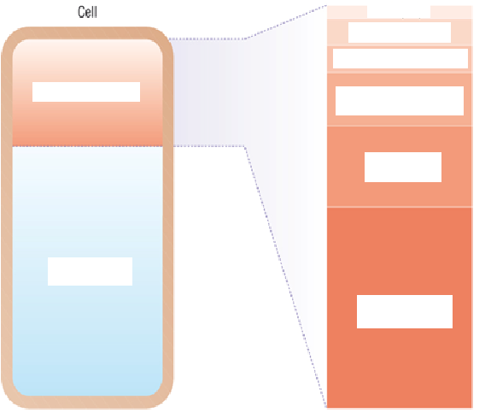

Task 5: Biological Monomers and Polymers (10 min)
Create a table in your books of the names of the biological monomers for carbohydratess, proteins and nucleic acids
Task 4: Explain to a year 10 student why carbon is special (20 min) don’t forget information about:
- Biological molecules being carbon based
- Carbon’s ability to form single and double bonds
- Carbon’s ability to form chains and rings

Use diagrams where necessary – complete your information on a separate sheet of A4, lined or plain you choose, it’s going into your books

