Looking at cells
Background
The history of microscopy dates back to Hooke (1665) and van Leeuwenhoek (1676) whose observations ultimately lead to development of the cell theory. The cell theory has four basic ideas:
- Cells are the smallest unit capable of independent life.
- Cells are the basic unit of all living organisms i.e. all living things are made of cells.
- Cells arise from other cells by a process of cell division.
- The cell contains information that acts as the instructions for growth. This information is passed on to new cells.

There 3 types of microscope used to study cells: light microscope, transmission electron microscope (TEM) and Scanning electron microscope (SEM). Modern light microscopes can achieve an effective magnification of up to 1500x and have a maximum resolving power of 200nm. Electron microscopes can achieve magnifications of up to 500000x and resolutions of 1nm.

Units of measurement

- Complete the diagram below to show: names of the units of measurement, unit symbols, mathematical operations for converting between units.

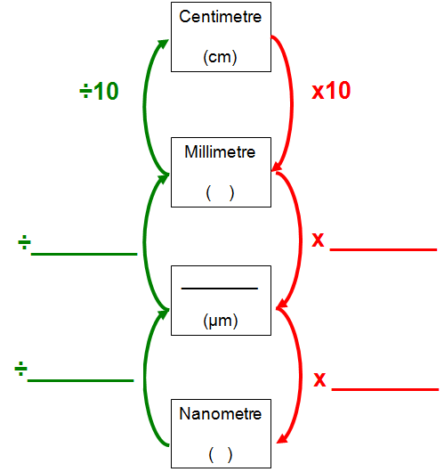

2). Complete the table below to show the corresponding value nanometres, micrometres and millimetres for the measurements given in each row. The first row has been completed for you. Ensure that your answers use the correct unit symbols.

Nanometre | Micrometre | Millimetre
5 | 0.005 | 0.000005
1
 | 1
 |  | 1
 | 3
7
 |  | 0.5

Magnification and Resolution

- Define the following terms:

Magnification:

Resolution:

- Visible light has a wavelength of 400-700 nm. Calculate the best resolution achievable with a light microscope? Show your working out:

- If the electron gun produces an electron beam with 2 nm wavelength, what is the best resolution achievable?

Calculating total Magnification of a compound light microscope

Eyepiece Magnification | Objective Magnification | Overall Magnification
X10 | X4
X10 | X10
X10 | X40
X10 | X100

Calculating Cell Magnification from images
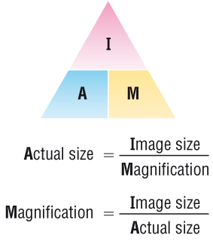
The diagram below shows the general structure of an animal cell as seen under an electron microscope.
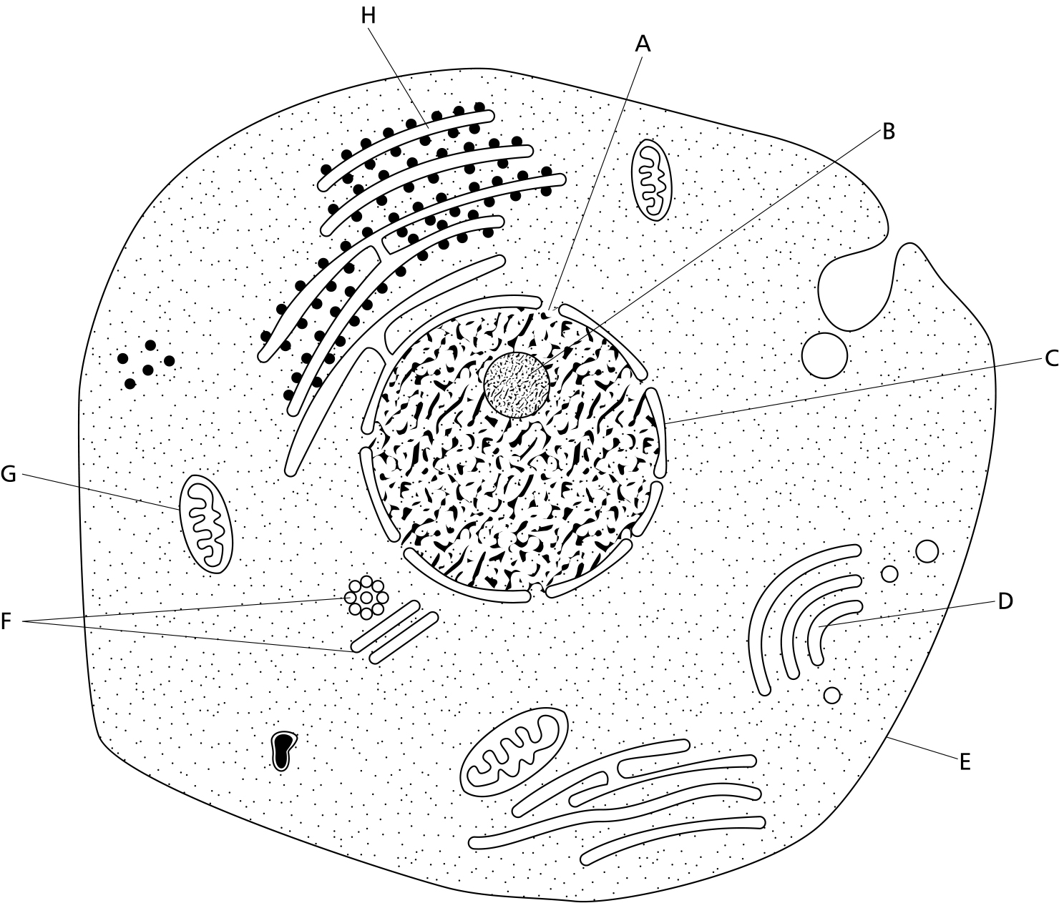

_________
5μm

- Calculate the magnification factor of the diagram

- Calculate the length of structure G

- Calculate the diameter of the nucleolus (structure B)

- Calculate the diameter of the nucleus

- Calculate the diameter of the cell at its widest point

The diagram below shows the general structure of a plant cell when viewed under and electron microscope.
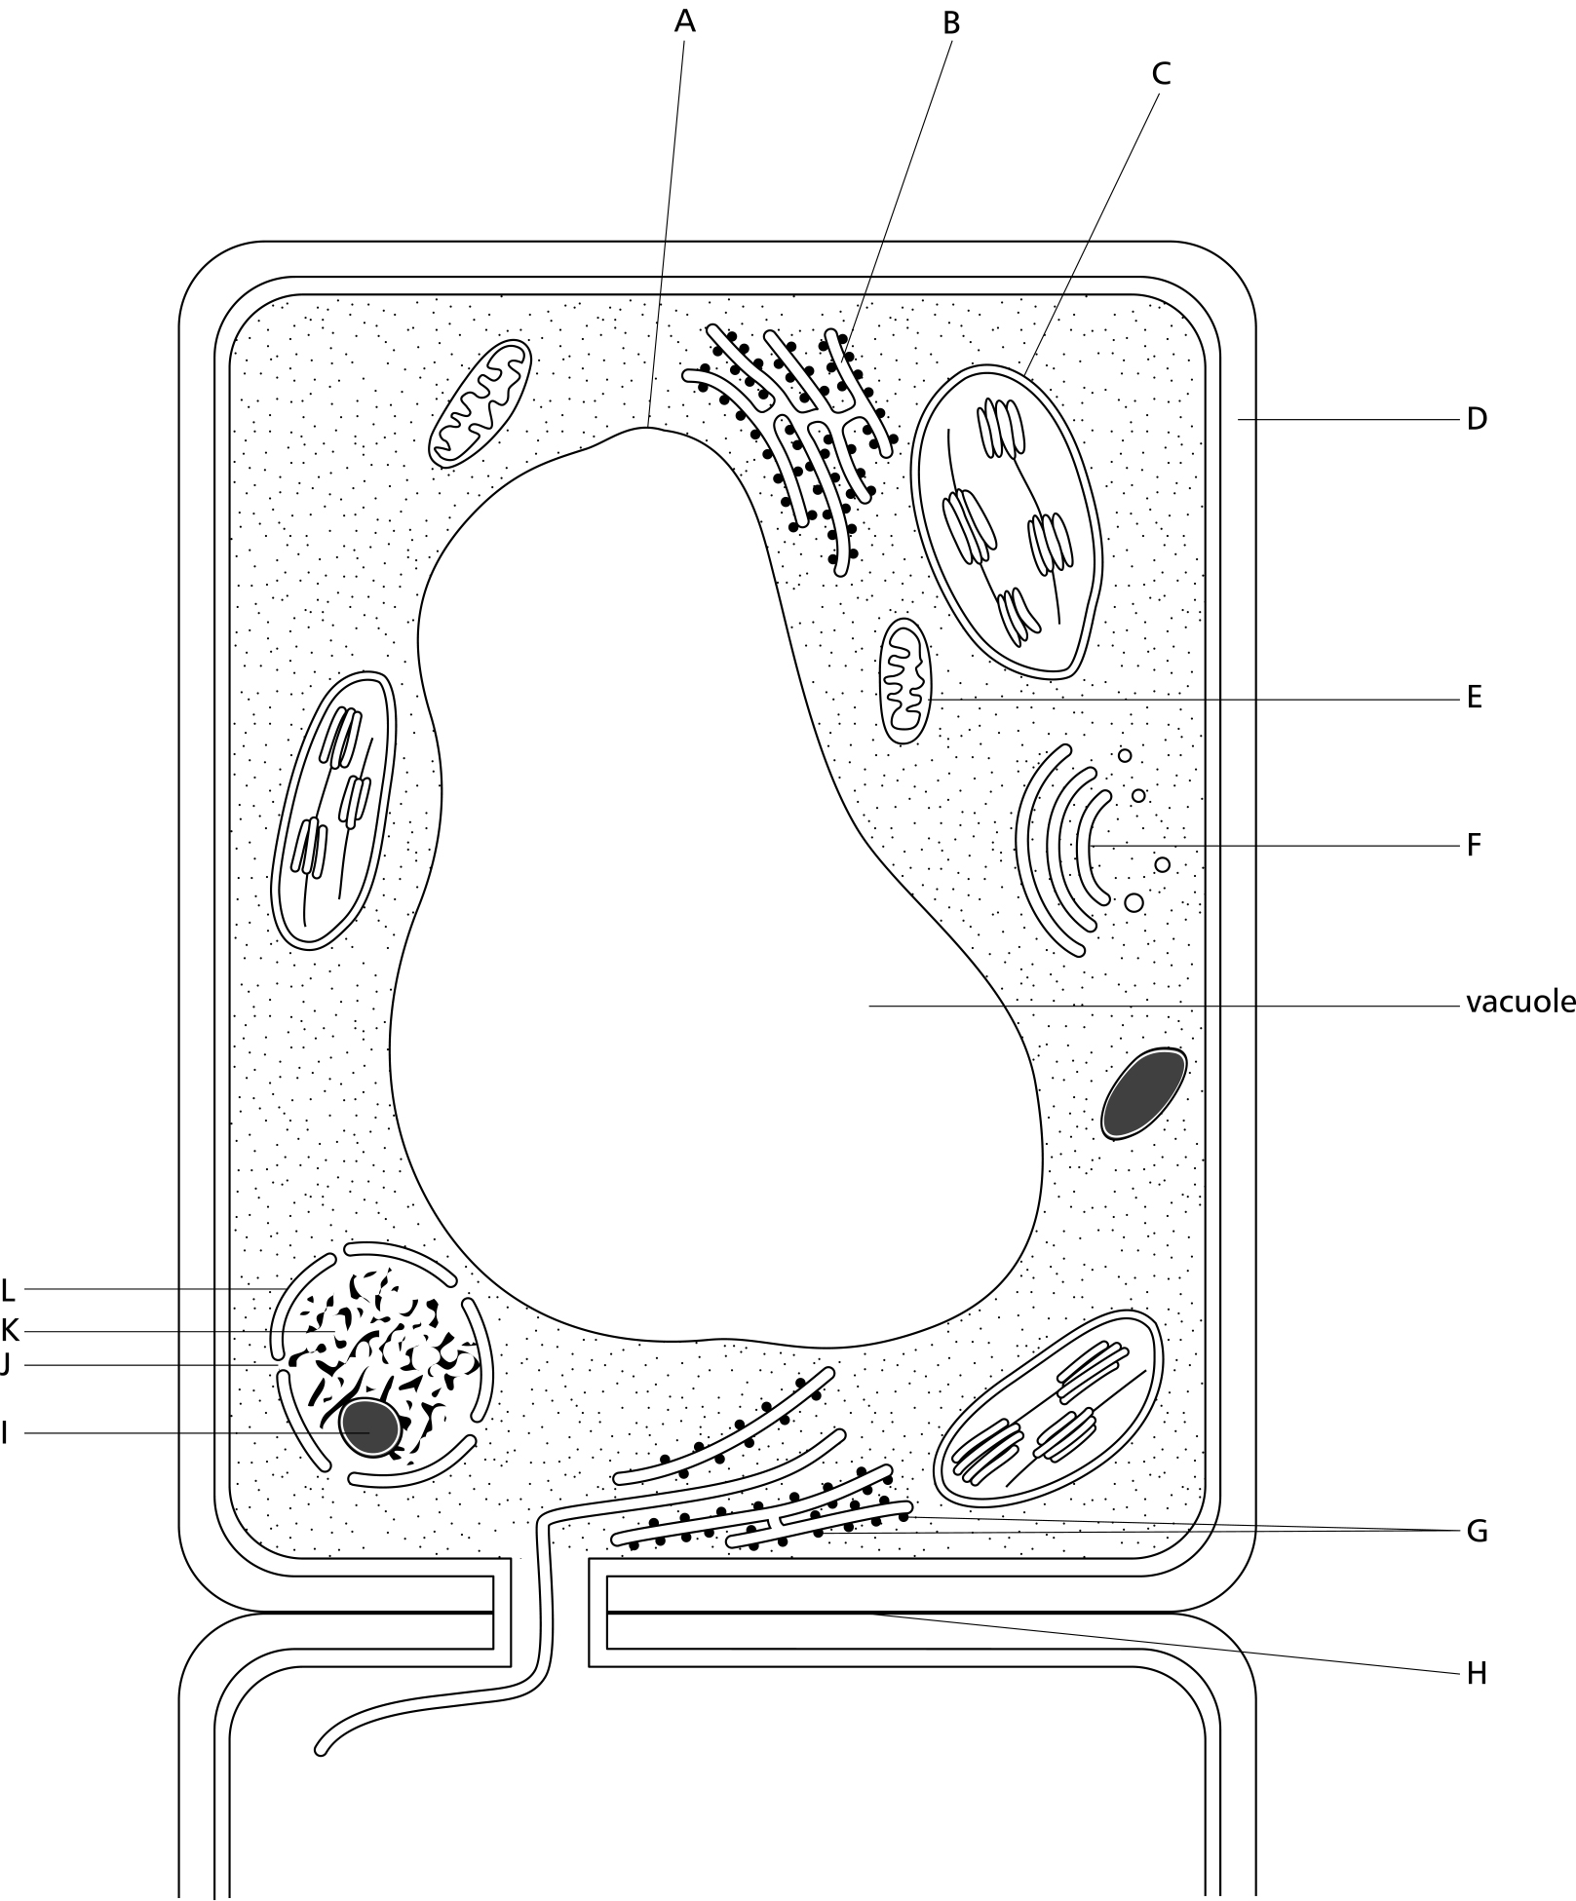
___________
40μm
- Calculate the magnification factor of the diagram

- Calculate the thickness of the cellulose cell wall.

- Calculate the length of the cell.

- Calculate the length of structure C.

- Calculate the length of the vacuole.

Types of microscope
- Why is the maximum effective magnification of a light microscope said to be 1500x when it is possible to produce higher magnifications with improved lenses?

- Use a named example to explain the need for staining when using a light microscope.

- State a possible disadvantage of staining a specimen for observation when using a light microscope

- State 2 advantages of using electron microscopes to study cells over a light microscope.

- State 2 disadvantages of using electron microscopes to study cells.

- Explain why a vacuum necessary in an electron microscope?

